**Smart health care kit**

*Author(s): Sai Sathyak, R Divya, L Rushali, Tharun*

*Date: 22/05/2019*

Revision: 0

Document Status: Draft

Project Status: In-Progress

Revision History

|  |  |  |  |
| --- | --- | --- | --- |
| Date | Revision | Description | Author |
| 22/05/2019 | 0 | Smart health care kit | *Sai Sathyak, R Divya, L Rushali, Tharun* |
|  |  |  |  |
|  |  |  |  |
|  |  |  |  |
|  |  |  |  |
|  |  |  |  |
|  |  |  |  |
|  |  |  |  |
|  |  |  |  |
|  |  |  |  |

# Introduction

## Summary

To handle the problem of “absentia” faced by people these days, where the user need to be reminded of their medication timings. These timings should be according to requirements of the user. We provide a device is to help the user locate their medical kit easily and warn the user about their particular medication timings.

**Background**

To handle the problem of “absentia” faced by people these days, where the user need to be reminded of their medication timings. These timings should be according to requirements of the user. Existing product has few drawbacks likeeverything has to be done manually by the user. It just act like a storage container. Present project is an automatic and user friendly. It alerts the user regarding the medication timings accordingly. It also warns the user about the capacity of the container. Cheap and best.

**DEFINITIONS, ACRONYMS, AND ABBREVIAIONS**

Definition of terms that will help readers understand the documents, or acronyms common in your project area

AI: Artificial intelligence is a software that allows humans to perform complex tasks easily. Generally we say that AI is cognitive because of its self learning datastreams which improve by themselves.

IOT: The internet of things, or IoT, is a system of interrelated computing devices, mechanical and digital machines, objects, animals or people that are provided with unique identifiers ([UIDs](https://internetofthingsagenda.techtarget.com/definition/unique-identifier-UID)) and the ability to transfer data over a network without requiring human-to-human or human-to-computer interaction.

# Design Overview

Project requirements, this can include requirements from customers, partners, or overseeing teams. The requirements for the project, this may include subsections for various types or sources of requirements

* ARDUINO UNO.
* BUZZER.
* TOUCH SENSOR.
* LED.
* SERVO MOTOR.
* CONNECTING WIRES.

**DOCUMENTATION**

If the project requires any wiki pages, code comments, presentations, etc. that information should be included here

SMART HEALTH CARE KIT-IEEE

**Minimum Viable Product**

Making charges include sensors which costs around Rs2000.

We assume our monthly revenue to be Rs 1,00,000 Cost=Rs 2000

Selling prize=Rs 2500

Profit=RS 500

## Stretch goals

Stretch goals include functionality beyond the scope of the minimum viable product that should be include in the project should time and budget permit. Unlike future work, stretch goals would be smaller tasks for features in support of the minimum viable product.

## Future work

This may include ongoing support, expansion of the original scope, work that requires transitions in project ownership, or details of projects designed to be broken up into multiple phases. No wait time Higher customer satisfaction Improved ease of use.

**ARCHITECTURAL DIAGRAMS:**

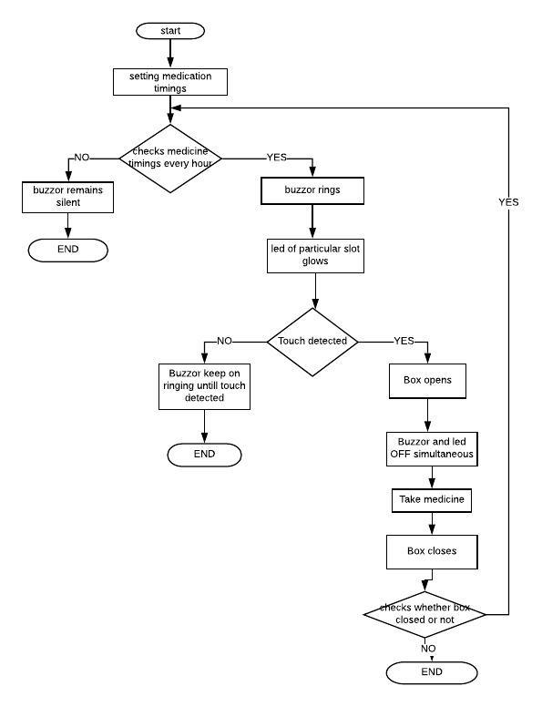

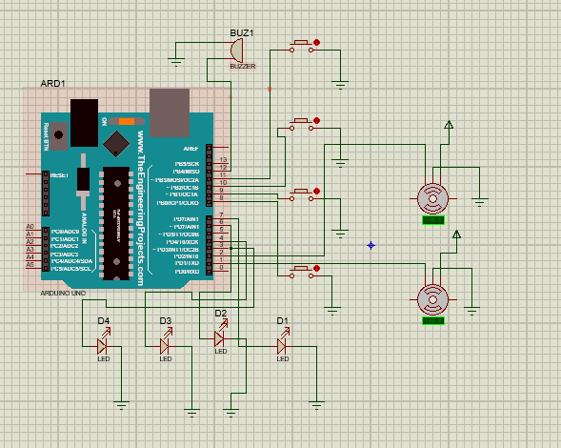

# Service Operability

## Key Performance Indicators

Key performance indicators (KPI), describe how a service should be monitored and how its performance can be gauged. This would typically include an overview of the types of metrics an application will need to emit, call time, error rate, etc.

## Service Level Objectives

Service level objectives (SLOs), set targets for various KPI through alerts via email or SMS, these targets may provide early indicators of approaching a capacity limit, changes in load patterns through various phases of an application, changes in duration of offline processing, etc.

# Frequently Asked Question

# References

Links to any supporting documentation, other projects, or reference material

# Addendum

Additional diagrams or details that do not particularly belong in the body of the design doc. This could also be a place to describe additional examples that would otherwise bloat the introduction section. More specifics on APIs could also be placed here for engineers to reference.